Editorial contacts:
Heiko Hespen or Nick Foot
Billings Europe
Tel: +44-1491-636 393
Fax: +44-1491-636 383
heiko.hespen@billings-europe.com

Low profile multi-function transducer features enhanced communication capabilities

Witham – March 13, 2007 – A new version of the low profile multi-function Integra 1630 digital metering system (DMS) benefiting from enhanced communication capabilities is now available from Tyco Electronics under the Crompton Instruments brand. The new Profibus™ option card fully supports the Profibus™ DPV1 protocol, developed by Siemens. It seamlessly integrates with Siemens‘ building management systems and other peripherals, providing a cost effective retro fit or new option in all scale developments.
Profibus™ option is also available as a plug in accessory for existing Integra 1630 DMS products.

Designed specifically to provide cost effective measurement for all power monitoring applications, multi-function Integra 1630 digital metering systems provide high accuracy <0.2% measurement, display and communication of all major electrical and power quality parameters, including true RMS system values, individual current demand, user programmable system type and elapsed time counter for connected loads.

Integra 1630 DMS’s low profile makes it ideal for use in switchgear applications but the device has also been designed for use in distribution systems, generator sets, control panels, energy and building management as well as utility power monitoring. Further applications include process control, motor monitoring, ground power units and embedded generation.

The DIN 96 panel mounted Integra 1630 DMS benefits from a user programmable system configuration as well as programmable VT and CT ratios. Once configured, simultaneous monitoring of up to 35 electrical and power parameters can be communicated via pulsed or Modbus outputs, allowing enhanced status information of up to 60 measured parameters to be communicated into building management systems. High contrast red LED displays clearly show each measured parameter.

If a very low profile measurement within the panel is required, a removable bezel is supplied to extend the product forward, reducing rear panel depth.

Additionally, a simple Windows based software package is available to remotely configure, monitor and communicate all 60 major electrical and power quality parameters.

Tyco Electronics is a trademark.
Crompton is a trademark of Crompton Parkinson Ltd., and used by Tyco Electronics under licence.
Profibus is a trademark of PROFIBUS Nutzerorganisation e.V.
Modbus is a trademark of Schneider Automation Inc.
Other trademarks or company names used herein are the property of respective owners.

About Tyco Electronics – Energy Division
The Energy Division of Tyco Electronics is a global manufacturer of products and systems for the electrical power industry. Its products are extensively employed by power utilities and equipment manufacturers, in rail transport systems and in industry around the world.
The Energy Division of Tyco Electronics offers a wide product range from brands such as AMP, Axicom, Dulmison, Raychem, SIMEL, Bowthorpe EMP, Crompton Instruments, Dorman Smith and Guro, including cable accessories, connectors and fittings, switching and power management devices, lighting protectors, surge arrestors and insulators.
For further information please visit: www.energy.tycoelectronics.com

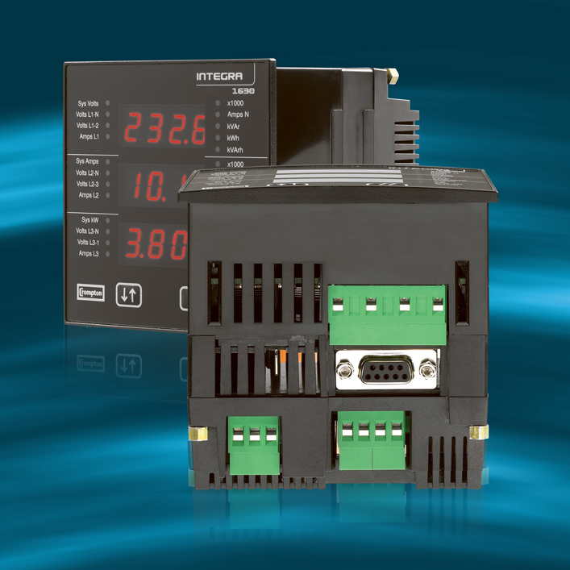

About Tyco Electronics
Tyco Electronics is a leading global provider of engineered electronic components, network solutions and wireless systems, with 2006 sales of $12.7 billion to customers in 150 countries. We design, manufacture and market products for customers in industries from automotive, appliances and aerospace and defence to telecommunications, computers and consumer electronics. With over 8,000 engineers and worldwide manufacturing, sales and customer service capabilities, Tyco Electronics' commitment is our customers' advantage. More information on Tyco Electronics can be found at www.tycoelectronics.com

For further information please refer to www.energy.tycoelectronics.com or contact:

Pavlina Dvorakova, Marketing Communications Coordinator,
Tyco Electronics – Energy Division, Witham, UK,
Tel: +44 (0)1376 509 509, Email: pavlina.dvorakova@tycoelectronics.com

